
Toso have been making wine in Italy for over a century, they remain a business that values its cultural heritage and family traditions. Respect for both traditional and modern vinification techniques combine to create a wine that is both classical and modern at the same time. Classically Prosecco was produced as a dry sweet wine with just a little fizz and heaps of freshness on the tongue. This more modern version of Prosecco Extra Dry retains the tradition of freshness but it is much dryer with more bubbles. The technology that Toso apply to each tank enables them to optimally control the temperature and pressure of the sparkling wine during fermentation thus ensuring the quality of the final product. This professional approach and attention to detail has earned Toso a reputation as prominent wine makers, which is why Piedmont Wine are delighted to add then to our list of preferred producers.

So why is Piedmont Wine selling Prosecco? Well the answer is simple, although the grapes are sourced from the home of Prosecco in the famous Veneto region of Italy; it is made here in Piedmont by our friends from TOSO in their cantina at Cossano Belbo. Also many of our clients who tasted the wine here in Italy have asked us to include it in our UK stock, so we have listened and here it is!

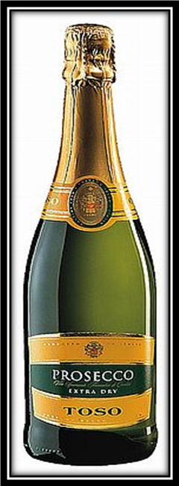
This Prosecco has been made by the Charmat method rather than the Champagne method of making sparkling wine. The Charmat method allows the wine complete secondary fermentation in pressurised stainless steel tanks, rather than in individual bottles. The shorter tank fermentation is important to Prosecco ability to maintain its freshness. The classic champagne method would involve aging the wine for several years [and a lot of bottle turning] which would negatively impact its taste of freshness. The great news is that this also makes Prosecco more affordable than champagne and Piedmont wine believe that this quality Prosecco from Toso represents great value for money.

PRODUCER TosoVariety of grape100 % ProseccoProduction areaVenetoAppellationProsecco DOCAlcohol Volume11%SoilCalcareous, clayeyHarvestingSeptemberFermentation8 - 10 daysAgeing before releaseNoBottlingNovemberServing temperatureChilled between 7-9°c

